Non supervised inverse PCA was giving unsatisfactory results so supervised method was developed to solve the issue.

Lr = 0.001, Adam

Loss = MAE

INVERSE PCA:

Inverse PCA performed by Fully Connected Dense Layer of 2048 neurons. From 30 features to 14\*3 = 42

( 3d hand joint locations).

Architecture no 1:

ARCHITECTURE :

30 DENSE -🡪 2048 DENSE LAYERS 🡪 42 DENSE LAYERS ( 3D JOINT POINTS )

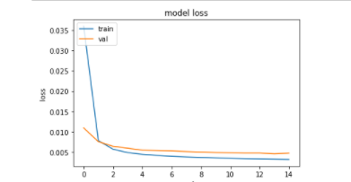

Architecture no 2:

ARCHITECTURE :

30 DENSE -🡪 1024 DENSE LAYERS 🡪 42 DENSE LAYERS ( 3D JOINT POINTS )

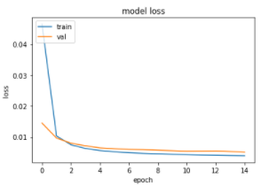

Architecture no 3:

ARCHITECTURE :

30 DENSE -🡪 64 DENSE LAYERS 🡪128 DENSE LAYERS 🡪 256 DENSE LAYERS 🡪 512 DENSE LAYERS🡪1024 DENSE LAYERS 🡪 🡪 42 DENSE LAYERS ( 3D JOINT POINTS )

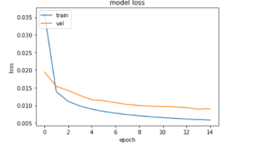

Architecture no 4:

ARCHITECTURE :

30 DENSE -🡪 256 DENSE LAYERS 🡪 4048 DENSE LAYERS 🡪 42 DENSE LAYERS ( 3D JOINT POINTS )

